**Deployed nginx application in kubernetes**

Installed minicube and kubectl

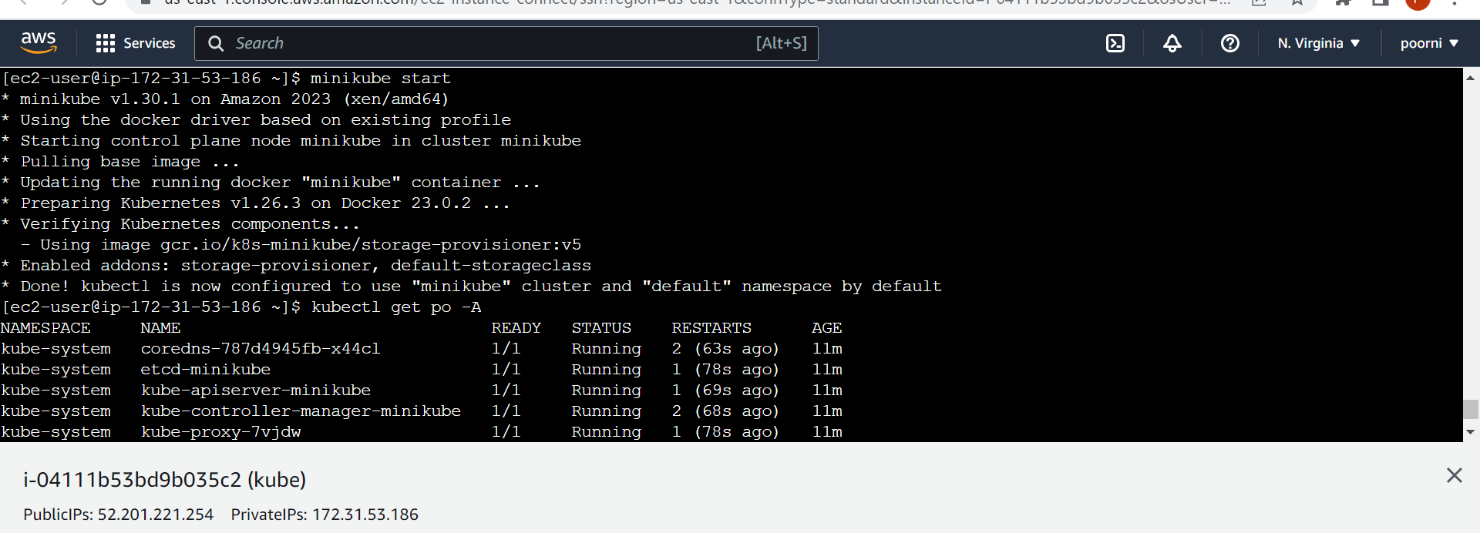

Created docker image using dockerfile

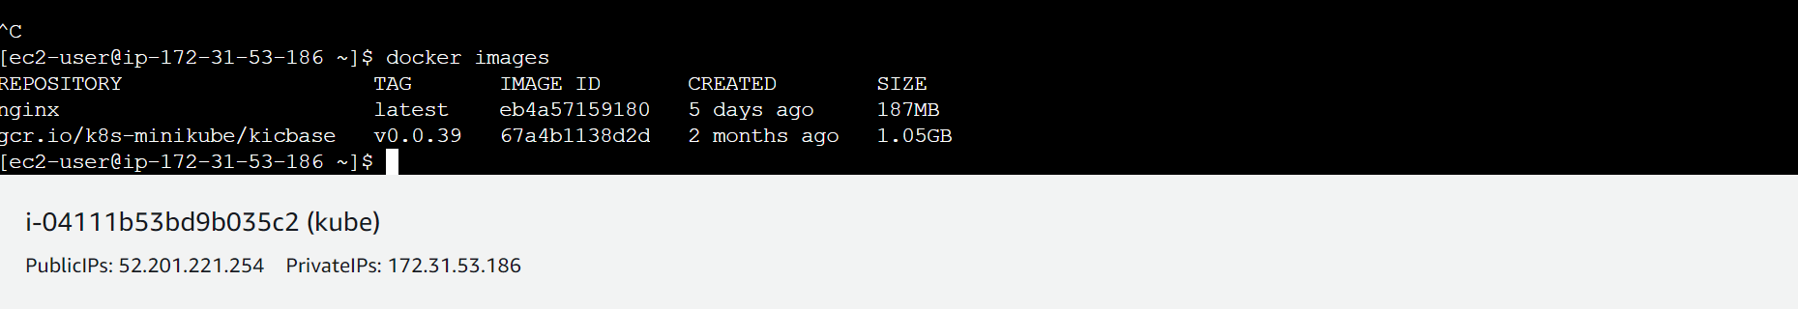

After deploying yaml

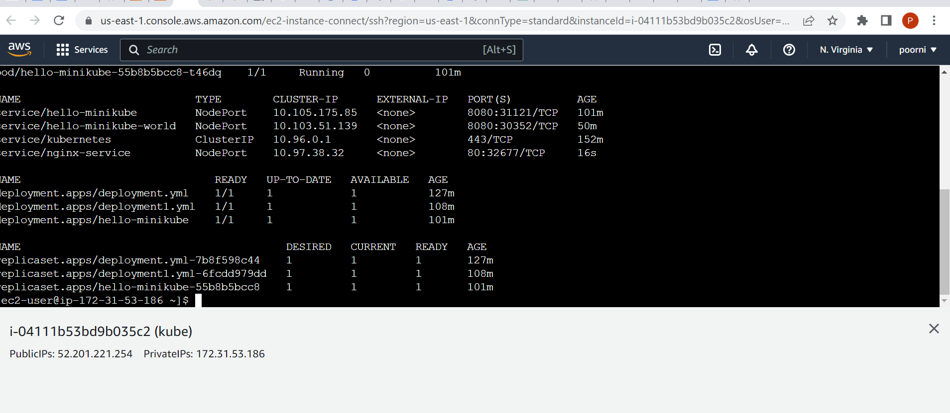

Generated secrete key

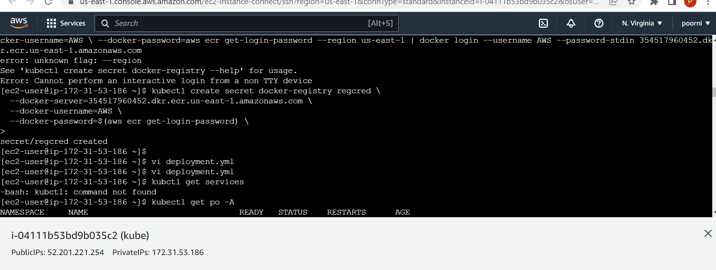

Successfully deployed nginx webpage

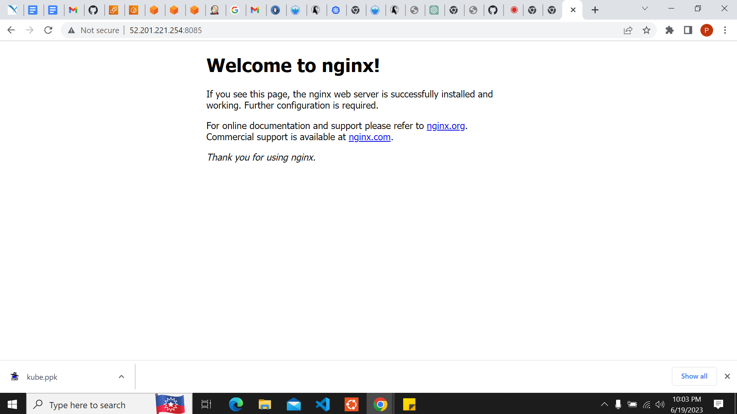

https://github.com/chandrushal/assessment_new.git